Redbus Project Documentation

Note : Please try to open it in Google docs for better visibility.

**Python code flow for Scraping the data from the Redbus website**

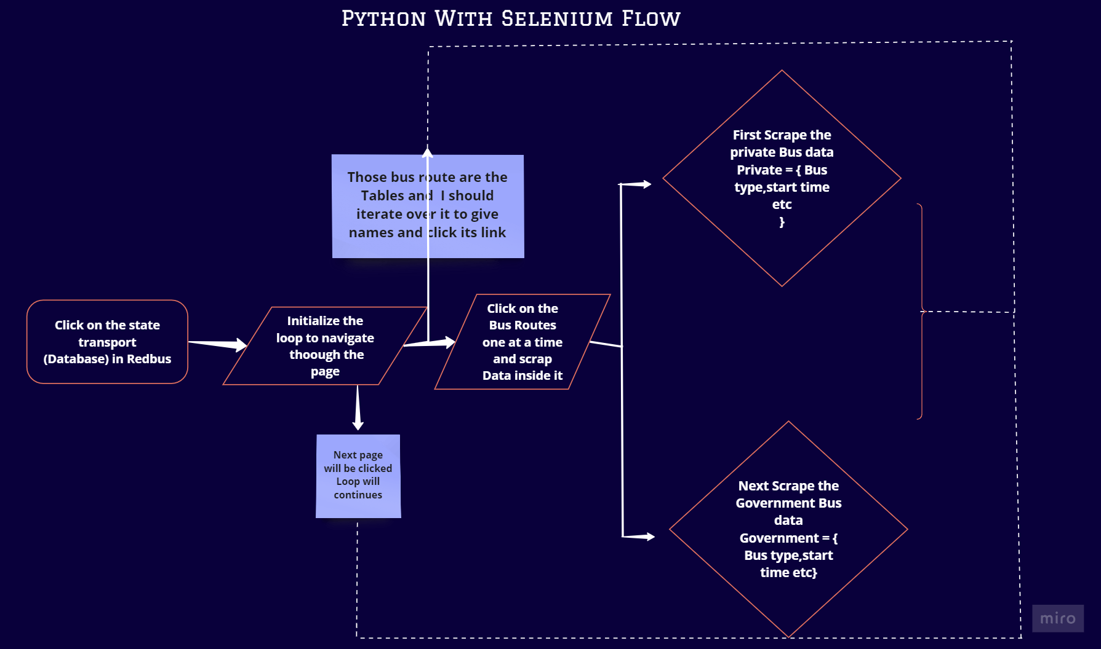

# Python Complete code:

import json

import time

from selenium import webdriver

from selenium.webdriver.common.by import By

from selenium.webdriver.support.ui import WebDriverWait

from selenium.webdriver.support import expected_conditions as EC

from selenium.common.exceptions import (

ElementNotInteractableException,

TimeoutException,

ElementClickInterceptedException,

NoSuchElementException

)

class Redbus:

def __init__(self, Xpath):

self.Xpath = Xpath

self.Bus = {}

# Initialize the Chrome driver

self.driver = webdriver.Chrome()

# Open the Redbus page

self.driver.get('https://www.redbus.in/')

time.sleep(5)

# Scroll horizontally to bring the element into view

target_element = WebDriverWait(self.driver, 20).until(EC.presence_of_element_located((By.XPATH, self.Xpath)))

self.driver.execute_script("arguments[0].scrollIntoView({block: 'center', inline: 'center'});", target_element)

time.sleep(2)

# Click on the state bus link

WebDriverWait(self.driver, 20).until(EC.element_to_be_clickable((By.XPATH, self.Xpath))).click()

time.sleep(10)

# Get the bus route links and names

Bus_Route_link = [i.get_attribute('href') for i in self.driver.find_elements(By.XPATH, "//div[@class='route_details']//a")]

Bus_Route_name = [i.text for i in self.driver.find_elements(By.XPATH, "//a[@class='route']")]

def smooth_scroll():

"""Function to scroll to the bottom of the page to ensure all elements are loaded."""

last_height = self.driver.execute_script("return document.body.scrollHeight")

while True:

# Scroll down to the bottom

self.driver.execute_script("window.scrollTo(0, document.body.scrollHeight);")

# Wait for new content to load

time.sleep(2)

# Calculate new scroll height and compare with last height

new_height = self.driver.execute_script("return document.body.scrollHeight")

if new_height == last_height:

break

last_height = new_height

for i in range(1, 6):

if i > 1:

# Refresh bus route links and names for subsequent pages

Bus_Route_link = [i.get_attribute('href') for i in self.driver.find_elements(By.XPATH, "//div[@class='route_details']//a")]

Bus_Route_name = [i.text for i in self.driver.find_elements(By.XPATH, "//a[@class='route']")]

for name, link in zip(Bus_Route_name, Bus_Route_link):

self.driver.get(link)

time.sleep(10)

self.Bus[name] = {"Private": {}, "Government": {}}

# Wait for elements to load and fetch private bus details

time.sleep(10)

try:

# Smooth scroll before scraping private bus details

smooth_scroll()

# Scrape private bus details

Bus_travel_Name, Bus_Confort_Type, Bus_start_time, Bus_end_time, Total_travel_time, Rating, Seat_availability, Price, Reach_date = WebDriverWait(self.driver, 25).until(

lambda driver: (

driver.find_elements(By.XPATH, "//div[@class='travels lh-24 f-bold d-color']"),

driver.find_elements(By.XPATH, "//div[@class='bus-type f-12 m-top-16 l-color evBus']"),

driver.find_elements(By.XPATH, "//div[@class='dp-time f-19 d-color f-bold']"),

driver.find_elements(By.XPATH, "//div[@class='bp-time f-19 d-color disp-Inline']"),

driver.find_elements(By.XPATH, "//div[@class='dur l-color lh-24']"),

driver.find_elements(By.XPATH, "//div[@class='rating-sec lh-24']//span"),

driver.find_elements(By.XPATH, "//div[@class='seat-left m-top-30']"),

driver.find_elements(By.XPATH, "//div[@class='fare d-block']"),

driver.find_elements(By.XPATH, "//div[@class='next-day-dp-lbl m-top-16']")

)

)

# Store scraped data for private buses

self.Bus[name]["Private"]["Bus_Name"] = [elem.text.strip() for elem in Bus_travel_Name if elem.text != '']

self.Bus[name]["Private"]["Bus_Type"] = [elem.text.strip() for elem in Bus_Confort_Type if elem.text != '']

self.Bus[name]["Private"]["Departing_Time"] = [elem.text.strip() for elem in Bus_start_time if elem.text != '']

self.Bus[name]["Private"]["Reaching_Time"] = [elem.text.strip() for elem in Bus_end_time if elem.text != '']

self.Bus[name]["Private"]["Duration"] = [elem.text.strip() for elem in Total_travel_time if elem.text != '']

self.Bus[name]["Private"]["Star_Rating"] = [float(elem.text.strip()) for elem in Rating if elem.text != '']

self.Bus[name]["Private"]["Seat_availability"] = [int(i.text.split()[0]) for i in Seat_availability if i.text != '']

self.Bus[name]["Private"]["Price"] = [i.text[3:].strip() for i in Price if i.text[3:] != '']

self.Bus[name]["Private"]["Reach_date"] = [elem.text.strip() for elem in Reach_date if elem.text != '']

# Click to switch to government buses

try:

button = WebDriverWait(self.driver, 15).until(EC.element_to_be_clickable((By.XPATH, "//div[@class='button']")))

# Scroll the button into view

self.driver.execute_script("arguments[0].scrollIntoView(true);", button)

time.sleep(1)

self.driver.execute_script("arguments[0].click();", button)

except ElementClickInterceptedException as e:

print(f"Error clicking the button to switch to government buses: {e}")

# Smooth scroll before scraping government bus details

smooth_scroll()

# Scrape government bus details

Bus_travel_Name, Bus_Confort_Type, Bus_start_time, Bus_end_time, Total_travel_time, Rating, Seat_availability, Price, Reach_date = WebDriverWait(self.driver, 25).until(

lambda driver: (

driver.find_elements(By.XPATH, "//div[@class='travels lh-24 f-bold d-color']"),

driver.find_elements(By.XPATH, "//div[@class='bus-type f-12 m-top-16 l-color evBus']"),

driver.find_elements(By.XPATH, "//div[@class='dp-time f-19 d-color f-bold']"),

driver.find_elements(By.XPATH, "//div[@class='bp-time f-19 d-color disp-Inline']"),

driver.find_elements(By.XPATH, "//div[@class='dur l-color lh-24']"),

driver.find_elements(By.XPATH, "//div[@class='rating-sec lh-24']//span"),

driver.find_elements(By.XPATH, "//div[@class='seat-left m-top-30']"),

driver.find_elements(By.XPATH, "//div[@class='fare d-block']"),

driver.find_elements(By.XPATH, "//div[@class='next-day-dp-lbl m-top-16']")

)

)

# Store scraped data for government buses

self.Bus[name]["Government"]["Bus_Name"] = [elem.text.strip() for elem in Bus_travel_Name if elem.text != '']

self.Bus[name]["Government"]["Bus_Type"] = [elem.text.strip() for elem in Bus_Confort_Type if elem.text != '']

self.Bus[name]["Government"]["Departing_Time"] = [elem.text.strip() for elem in Bus_start_time if elem.text != '']

self.Bus[name]["Government"]["Reaching_Time"] = [elem.text.strip() for elem in Bus_end_time if elem.text != '']

self.Bus[name]["Government"]["Duration"] = [elem.text.strip() for elem in Total_travel_time if elem.text != '']

self.Bus[name]["Government"]["Star_Rating"] = [float(elem.text.strip()) for elem in Rating if elem.text != '']

self.Bus[name]["Government"]["Seat_availability"] = [int(i.text.split()[0]) for i in Seat_availability if i.text != '']

self.Bus[name]["Government"]["Price"] = [i.text[3:].strip() for i in Price if i.text[3:] != '']

self.Bus[name]["Government"]["Reach_date"] = [elem.text.strip() for elem in Reach_date if elem.text != '']

except TimeoutException as e:

print(f"Error fetching bus details for {name}: {e}")

# Navigate back and handle pagination

try:

time.sleep(7)

self.driver.get('https://www.redbus.in/')

time.sleep(5)

# Scroll horizontally to bring the element into view

target_element = WebDriverWait(self.driver, 20).until(EC.presence_of_element_located((By.XPATH, self.Xpath)))

self.driver.execute_script("arguments[0].scrollIntoView({block: 'center', inline: 'center'});", target_element)

time.sleep(2)

WebDriverWait(self.driver, 20).until(EC.element_to_be_clickable((By.XPATH, self.Xpath))).click()

time.sleep(10)

xpath = f"//div[12]/div[{i + 1}]"

# Check if the element exists

if not self.driver.find_elements(By.XPATH, xpath):

print(f"Page {i + 1} does not exist. Exiting loop.")

break

# Wait for the element to be present and visible

element = WebDriverWait(self.driver, 25).until(EC.visibility_of_element_located((By.XPATH, xpath)))

# Scroll the element into view before clicking

self.driver.execute_script("arguments[0].scrollIntoView(true);", element)

time.sleep(1)

# Attempt to click the element

element.click()

except ElementNotInteractableException as e:

print(f"Error navigating to page {i + 1}: {e}")

except ElementClickInterceptedException as e:

print(f"Click intercepted when trying to navigate to page {i + 1}: {e}")

except TimeoutException or NoSuchElementException as e:

print(f"Page is over {i + 1}: {e}")

# Close the WebDriver

self.driver.quit()

def get_bus_data(self):

"""Return the scraped bus data."""

return self.Bus

# Creating an instance of Redbus

Buses = Redbus("//div[@class='rtcNameMain']/div[@class='rtcName' and text()='JKSRTC']")

Value = Buses.get_bus_data()

## 

## **Import Section:**

Imported various modules based on the requirement and time module is for the implementing the sleep in between the page or sessions navigations and also added a exceptions handling for catching the various error and run without any errors

import json

import time

from selenium import webdriver

from selenium.webdriver.common.by import By

from selenium.webdriver.support.ui import WebDriverWait

from selenium.webdriver.support import expected_conditions as EC

from selenium.common.exceptions import (

ElementNotInteractableException,

TimeoutException,

ElementClickInterceptedException,

NoSuchElementException

## **Defining the class and getting into the redbus website:**

Creating the class for the code reusability and defining it with the name redbus it will take only one argument which is the path to clicking the right state transport page in red bus website and self.bus will store the final scraped Bus data it will first get into the <https://www.redbus.in> page and scroll till the text visible it will click the respective page that I have given as a argument

class Redbus:

def __init__(self, Xpath):

self.Xpath = Xpath

self.Bus = {} # Storing the Bus dictionary as an instance variable

# Initialize the Chrome driver

self.driver = webdriver.Chrome()

# Open the Redbus page

self.driver.get('https://www.redbus.in/')

time.sleep(5)

# Scroll horizontally to bring the element into view

target_element = WebDriverWait(self.driver, 20).until(EC.presence_of_element_located((By.XPATH, self.Xpath)))

self.driver.execute_script("arguments[0].scrollIntoView({block: 'center', inline: 'center'});", target_element)

time.sleep(2)

# Click on the state bus link

WebDriverWait(self.driver, 20).until(EC.element_to_be_clickable((By.XPATH, self.Xpath))).click()

time.sleep(10)

## 

## **Creating the Scroll function and storing the Bus route name and Bus route link for accessing it:**

This Bus_Route_link and Bus_Route_name will store the first page name and link and i have included a Smooth_scroll function because without this it only take first 5 to 6 data only so I include this after this the page is scrolled smoothly and i can able to scrape all the data I want

def smooth_scroll():

"""Function to scroll to the bottom of the page to ensure all elements are loaded."""

last_height = self.driver.execute_script("return document.body.scrollHeight")

while True:

# Scroll down to the bottom

self.driver.execute_script("window.scrollTo(0, document.body.scrollHeight);")

# Wait for new content to load

time.sleep(2)

# Calculate new scroll height and compare with last height

new_height = self.driver.execute_script("return document.body.scrollHeight")

if new_height == last_height:

break

last_height = new_height

Bus_Route_link = [i.get_attribute('href') for i in self.driver.find_elements(By.XPATH, "//div[@class='route_details']//a")]

Bus_Route_name = [i.text for i in self.driver.find_elements(By.XPATH, "//a[@class='route']")]

## 

## **Page Navigation loop and to scrape the Bus details:**

Since the Redbus doesn't have more than 5 pages i have set my loop maximum range is 6 and I again included the same logic to scrape Bus_Route_link and Bus_Route_name but this time it will scrape the detail only when the page is greater than 1 so i will scrape detail from second page and it will reset every time.

In try block the process will repeat and scroll to view the page number if the page is there means it will click if it was not there means it will break the loop and quit.

In exception block it has ElementNotInteractableException,ElementClickInterceptedException TimeoutException and NoSuchElementException so the program runs flawlessly it will have the error with stopping the program

for i in range(1, 6):

if i > 1:

# Refresh bus route links and names for subsequent pages

Bus_Route_link = [i.get_attribute('href') for i in self.driver.find_elements(By.XPATH, "//div[@class='route_details']//a")]

Bus_Route_name = [i.text for i in self.driver.find_elements(By.XPATH, "//a[@class='route']")]

# Page handling Logic

# Navigate back and handle pagination

try:

time.sleep(7)

self.driver.get('https://www.redbus.in/')

time.sleep(5)

# Scroll horizontally to bring the element into view

target_element = WebDriverWait(self.driver, 20).until(EC.presence_of_element_located((By.XPATH, self.Xpath)))

self.driver.execute_script("arguments[0].scrollIntoView({block: 'center', inline: 'center'});", target_element)

time.sleep(2)

WebDriverWait(self.driver, 20).until(EC.element_to_be_clickable((By.XPATH, self.Xpath))).click()

time.sleep(10)

xpath = f"//div[12]/div[{i + 1}]"

# Check if the element exists

if not self.driver.find_elements(By.XPATH, xpath):

print(f"Page {i + 1} does not exist. Exiting loop.")

break

# Wait for the element to be present and visible

element = WebDriverWait(self.driver, 25).until(EC.visibility_of_element_located((By.XPATH, xpath)))

# Scroll the element into view before clicking

self.driver.execute_script("arguments[0].scrollIntoView(true);", element)

time.sleep(1) # Optional: Wait for any animations or loading to settle

# Attempt to click the element

element.click()

except ElementNotInteractableException as e:

print(f"Error navigating to page {i + 1}: {e}")

except ElementClickInterceptedException as e:

print(f"Click intercepted when trying to navigate to page {i + 1}: {e}")

except TimeoutException or NoSuchElementException as e:

print(f"Page is over {i + 1}: {e}")

## Private Bus data scraping

In this block the Bus_Route_name and Bus_Route_link is zip together to access it simultaneously in the dictionary is Bus name is a key in side there are two nested key Private and Government inside that there are nested key have various bus details that is scraped from the redbus website the private bus details is scraped using this code and the sleep time is also optimized so it will start scraping after page loaded and lambda function is used to point out or map the path to the variable and store the scraped data in that variable by that specific path while before storing it inside a Private dictionary it was extracted properly using list comprehension as per the needs so the Private bus detail is scraped successfully

for name, link in zip(Bus_Route_name, Bus_Route_link):

self.driver.get(link)

time.sleep(10)

self.Bus[name] = {"Private": {}, "Government": {}}

# Wait for elements to load and fetch private bus details

time.sleep(10) # Adjust as needed

try:

# Smooth scroll before scraping private bus details

smooth_scroll()

# Scrape private bus details

Bus_travel_Name, Bus_Confort_Type, Bus_start_time, Bus_end_time, Total_travel_time, Rating, Seat_availability, Price, Reach_date = WebDriverWait(self.driver, 25).until(

lambda driver: (

driver.find_elements(By.XPATH, "//div[@class='travels lh-24 f-bold d-color']"),

driver.find_elements(By.XPATH, "//div[@class='bus-type f-12 m-top-16 l-color evBus']"),

driver.find_elements(By.XPATH, "//div[@class='dp-time f-19 d-color f-bold']"),

driver.find_elements(By.XPATH, "//div[@class='bp-time f-19 d-color disp-Inline']"),

driver.find_elements(By.XPATH, "//div[@class='dur l-color lh-24']"),

driver.find_elements(By.XPATH, "//div[@class='rating-sec lh-24']//span"),

driver.find_elements(By.XPATH, "//div[@class='seat-left m-top-30']"),

driver.find_elements(By.XPATH, "//div[@class='fare d-block']"),

driver.find_elements(By.XPATH, "//div[@class='next-day-dp-lbl m-top-16']")

)

)

# Store scraped data for private buses

self.Bus[name]["Private"]["Bus_Name"] = [elem.text.strip() for elem in Bus_travel_Name if elem.text != '']

self.Bus[name]["Private"]["Bus_Type"] = [elem.text.strip() for elem in Bus_Confort_Type if elem.text != '']

self.Bus[name]["Private"]["Departing_Time"] = [elem.text.strip() for elem in Bus_start_time if elem.text != '']

self.Bus[name]["Private"]["Reaching_Time"] = [elem.text.strip() for elem in Bus_end_time if elem.text != '']

self.Bus[name]["Private"]["Duration"] = [elem.text.strip() for elem in Total_travel_time if elem.text != '']

self.Bus[name]["Private"]["Star_Rating"] = [float(elem.text.strip()) for elem in Rating if elem.text != '']

self.Bus[name]["Private"]["Seat_availability"] = [int(i.text.split()[0]) for i in Seat_availability if i.text != '']

self.Bus[name]["Private"]["Price"] = [i.text[3:].strip() for i in Price if i.text[3:] != '']

self.Bus[name]["Private"]["Reach_date"] = [elem.text.strip() for elem in Reach_date if elem.text != '']

## Government Bus data scraping:

After completion and storing the private bus data it will scrape the government bus data first it will click if there is any error means it will catch and try again

Bus name is a key in side there are two nested key Private and Government inside that there are nested key have various bus details that is scraped from the redbus website the Government bus details is scraped using this code and the sleep time is also optimized so it will start scraping after page loaded and lambda function is used to point out or map the path to the variable and store the scraped data in that variable by that specific path while before storing it inside a Government dictionary it was extracted properly using list comprehension as per the needs so the Government bus detail is scraped successfully

It will also handel the page not found error so that even if there is no bus available at the time of scraping also it will scrape without any error it will just skips that particular bus details

try:

button = WebDriverWait(self.driver, 15).until(EC.element_to_be_clickable((By.XPATH, "//div[@class='button']")))

# Scroll the button into view

self.driver.execute_script("arguments[0].scrollIntoView(true);", button)

time.sleep(1) # Optional: Wait a moment for any animations or loading to settle

# Click the button using JavaScript as a fallback

self.driver.execute_script("arguments[0].click();", button)

except ElementClickInterceptedException as e:

print(f"Error clicking the button to switch to government buses: {e}")

# Smooth scroll before scraping government bus details

smooth_scroll()

# Scrape government bus details

Bus_travel_Name, Bus_Confort_Type, Bus_start_time, Bus_end_time, Total_travel_time, Rating, Seat_availability, Price, Reach_date = WebDriverWait(self.driver, 25).until(

lambda driver: (

driver.find_elements(By.XPATH, "//div[@class='travels lh-24 f-bold d-color']"),

driver.find_elements(By.XPATH, "//div[@class='bus-type f-12 m-top-16 l-color evBus']"),

driver.find_elements(By.XPATH, "//div[@class='dp-time f-19 d-color f-bold']"),

driver.find_elements(By.XPATH, "//div[@class='bp-time f-19 d-color disp-Inline']"),

driver.find_elements(By.XPATH, "//div[@class='dur l-color lh-24']"),

driver.find_elements(By.XPATH, "//div[@class='rating-sec lh-24']//span"),

driver.find_elements(By.XPATH, "//div[@class='seat-left m-top-30']"),

driver.find_elements(By.XPATH, "//div[@class='fare d-block']"),

driver.find_elements(By.XPATH, "//div[@class='next-day-dp-lbl m-top-16']")

)

)

# Store scraped data for government buses

self.Bus[name]["Government"]["Bus_Name"] = [elem.text.strip() for elem in Bus_travel_Name if elem.text != '']

self.Bus[name]["Government"]["Bus_Type"] = [elem.text.strip() for elem in Bus_Confort_Type if elem.text != '']

self.Bus[name]["Government"]["Departing_Time"] = [elem.text.strip() for elem in Bus_start_time if elem.text != '']

self.Bus[name]["Government"]["Reaching_Time"] = [elem.text.strip() for elem in Bus_end_time if elem.text != '']

self.Bus[name]["Government"]["Duration"] = [elem.text.strip() for elem in Total_travel_time if elem.text != '']

self.Bus[name]["Government"]["Star_Rating"] = [float(elem.text.strip()) for elem in Rating if elem.text != '']

self.Bus[name]["Government"]["Seat_availability"] = [int(i.text.split()[0]) for i in Seat_availability if i.text != '']

self.Bus[name]["Government"]["Price"] = [i.text[3:].strip() for i in Price if i.text[3:] != '']

self.Bus[name]["Government"]["Reach_date"] = [elem.text.strip() for elem in Reach_date if elem.text != '']

except TimeoutException as e:

print(f"Error fetching bus details for {name}: {e}")

## 

## 

## Passing the argument inside the class and getting the data:

Finally I can pass the text of the bus that I need to scrape and the program will scrape the data and I can access the data by the method get_bus_data with an object Buses

def get_bus_data(self):

"""Return the scraped bus data."""

return self.Bus

# Creating an instance of Redbus

Buses = Redbus("//div[@class='rtcNameMain']/div[@class='rtcName' and text()='JKSRTC']")

Value = Buses.get_bus_data()

This is how I scraped the data from the redbus website. Let's go to the importing part of the data I have collected and import it into the Sql database effectively.

SQL data collection flow:

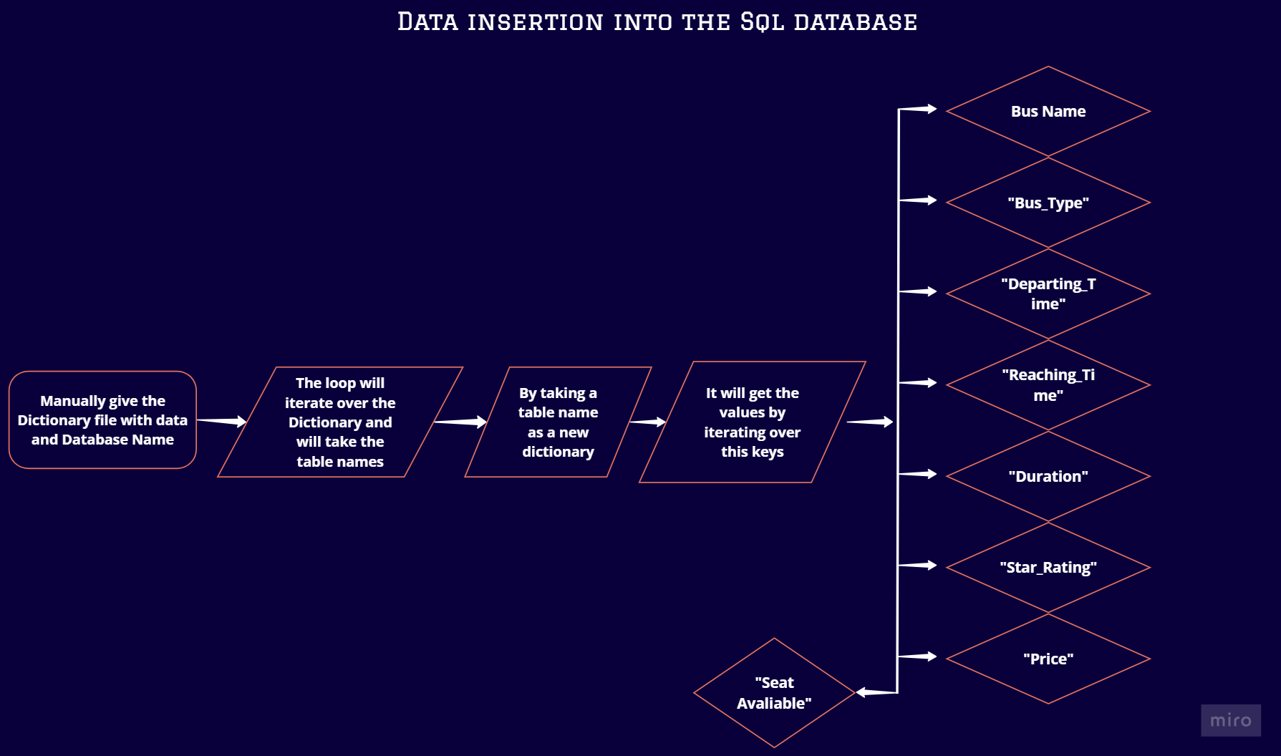

# 

# SQL Importing Complete Code:

import mysql.connector

class Importing:

def __init__(self, Table_insert, database_name):

self.Table_insert = Table_insert

self.database_name = database_name

# Connect to MySQL

self.mydb = mysql.connector.connect(

host="localhost",

user="root",

password="",

autocommit=True # Enable autocommit

)

print(self.mydb)

self.mycursor = self.mydb.cursor(buffered=True)

# Create the database

self.mycursor.execute(f"CREATE DATABASE IF NOT EXISTS {self.database_name}")

self.mycursor.execute(f"USE {self.database_name}") # Switch to the new database

self.table_names = [i for i in self.Table_insert]

print(self.table_names)

# Create tables

for table_name in self.table_names:

# Escape table names with backticks to handle spaces and reserved keywords

table_name_1 = f"`{table_name}`"

# Create the table with the specified schema

self.mycursor.execute(f"""

CREATE TABLE {table_name_1} (

id INT NOT NULL AUTO_INCREMENT,

Bus_Operator_type VARCHAR(15),

BusName VARCHAR(50),

BusType VARCHAR(15),

Departing_Time TIME,

Duration VARCHAR(30),

Reaching_Time TIME,

Star_rating FLOAT(5),

Price FLOAT(5),

Seats_available INT(5),

PRIMARY KEY (id)

)

""")

# Insert data into the tables

for table_name in self.table_names:

table_name_1 = f"`{table_name}`"

print(f"Inserting data for table: {table_name}")

for operator_type in ['Private', 'Government']:

print(f"Inserting data for operator type: {operator_type}")

try:

bus_name = self.Table_insert[table_name][operator_type]['Bus_Name']

bus_type = self.Table_insert[table_name][operator_type]['Bus_Type']

departing_time = self.Table_insert[table_name][operator_type]['Departing_Time']

duration = self.Table_insert[table_name][operator_type]['Duration']

reaching_time = self.Table_insert[table_name][operator_type]['Reaching_Time']

star_rating = self.Table_insert[table_name][operator_type]['Star_Rating']

price = self.Table_insert[table_name][operator_type]['Price']

seats_available = self.Table_insert[table_name][operator_type]['Seat_availability']

except KeyError as e:

print(f"KeyError: {e} in table {table_name} for operator type {operator_type}. Skipping...")

continue

insert_query = f"INSERT INTO {table_name_1} (Bus_Operator_type, BusName, BusType, Departing_Time, Duration, Reaching_Time, Star_rating, Price, Seats_available) VALUES (%s, %s, %s, %s, %s, %s, %s, %s, %s)"

# Get the minimum length among the lists to avoid index errors

value_lengths = [len(i) for i in [bus_name, bus_type, departing_time, duration, reaching_time, star_rating, price, seats_available]]

min_length = min(value_lengths)

print(f"Minimum length of lists: {min_length}")

# Insert each value in the list as a separate row

for i in range(min_length):

print(f"Inserting row {i+1} for {table_name} - {operator_type}")

print((

operator_type,

bus_name[i],

bus_type[i],

departing_time[i],

duration[i],

reaching_time[i],

star_rating[i],

price[i],

seats_available[i]

))

self.mycursor.execute(insert_query, (

operator_type,

bus_name[i],

bus_type[i],

departing_time[i],

duration[i],

reaching_time[i],

star_rating[i],

price[i],

seats_available[i]

))

self.mydb.commit() # Commit after each insertion

importer = Importing(JKSRTC_Buses, "JKSRTC_Buses")

## Import section and Defining the class:

Here I was importing the mysql connection for connecting the my sql server and i have taking two thing as a input first one is for accessing the route name for creating the table and inserting the values inside it to the sql database and second one is the database name for creating the database finally extracting the routes using the list comprehension.

import mysql.connector

class Importing:

def __init__(self, Table_insert, database_name):

self.Table_insert = Table_insert

self.database_name = database_name

# Connect to MySQL

self.mydb = mysql.connector.connect(

host="localhost",

user="root",

password="",

autocommit=True # Enable autocommit

)

print(self.mydb)

self.mycursor = self.mydb.cursor(buffered=True)

# Create the database

self.mycursor.execute(f"CREATE DATABASE IF NOT EXISTS {self.database_name}")

self.mycursor.execute(f"USE {self.database_name}") # Switch to the new database

self.table_names = [i for i in self.Table_insert]

print(self.table_names)

## **Creating a table and defining the data types:**

Since the route contains keywords such as to I have used a backticks to avoid that and given the proper data types as they mentioned.

for table_name in self.table_names:

# Escape table names with backticks to handle spaces and reserved keywords

table_name_1 = f"`{table_name}`"

# Create the table with the specified schema

self.mycursor.execute(f"""

CREATE TABLE {table_name_1} (

id INT NOT NULL AUTO_INCREMENT,

Bus_Operator_type VARCHAR(15),

BusName VARCHAR(50),

BusType VARCHAR(15),

Departing_Time TIME,

Duration VARCHAR(30),

Reaching_Time TIME,

Star_rating FLOAT(5),

Price FLOAT(5),

Seats_available INT(5),

PRIMARY KEY (id)

)

""")

**Inserting the data in to the table:**

Now using the loop and the accessing the key inside the dictionary i have inserted a values in a rows and i have also implemented a try-except statement so if there is any key error is found means it won’t shows any error it just skips that element and continue to the next one

# Insert data into the tables

for table_name in self.table_names:

table_name_1 = f"`{table_name}`"

print(f"Inserting data for table: {table_name}")

for operator_type in ['Private', 'Government']:

print(f"Inserting data for operator type: {operator_type}")

try:

bus_name = self.Table_insert[table_name][operator_type]['Bus_Name']

bus_type = self.Table_insert[table_name][operator_type]['Bus_Type']

departing_time = self.Table_insert[table_name][operator_type]['Departing_Time']

duration = self.Table_insert[table_name][operator_type]['Duration']

reaching_time = self.Table_insert[table_name][operator_type]['Reaching_Time']

star_rating = self.Table_insert[table_name][operator_type]['Star_Rating']

price = self.Table_insert[table_name][operator_type]['Price']

seats_available = self.Table_insert[table_name][operator_type]['Seat_availability']

except KeyError as e:

print(f"KeyError: {e} in table {table_name} for operator type {operator_type}. Skipping...")

continue

insert_query = f"INSERT INTO {table_name_1} (Bus_Operator_type, BusName, BusType, Departing_Time, Duration, Reaching_Time, Star_rating, Price, Seats_available) VALUES (%s, %s, %s, %s, %s, %s, %s, %s, %s)"

## **Inserting the values using the Keys:**

In this the values inside the each keys are regular for some reason so I have decided to go with min value to avoid the index error and for some routes the government buses are empty or not available for that I have used try-except to handle that issue and finally I have given commit to save the process in database and If I given the arguments means the process will starts and complete the insertion process

value_lengths = [len(i) for i in [bus_name, bus_type, departing_time, duration, reaching_time, star_rating, price, seats_available]]

min_length = min(value_lengths)

print(f"Minimum length of lists: {min_length}")

# Insert each value in the list as a separate row

for i in range(min_length):

print(f"Inserting row {i+1} for {table_name} - {operator_type}")

print((

operator_type,

bus_name[i],

bus_type[i],

departing_time[i],

duration[i],

reaching_time[i],

star_rating[i],

price[i],

seats_available[i]

))

self.mycursor.execute(insert_query, (

operator_type,

bus_name[i],

bus_type[i],

departing_time[i],

duration[i],

reaching_time[i],

star_rating[i],

price[i],

seats_available[i]

))

self.mydb.commit() # Commit after each insertion

importer = Importing(JKSRTC_Buses, "JKSRTC_Buses")

**Streamlit view flow and design:**

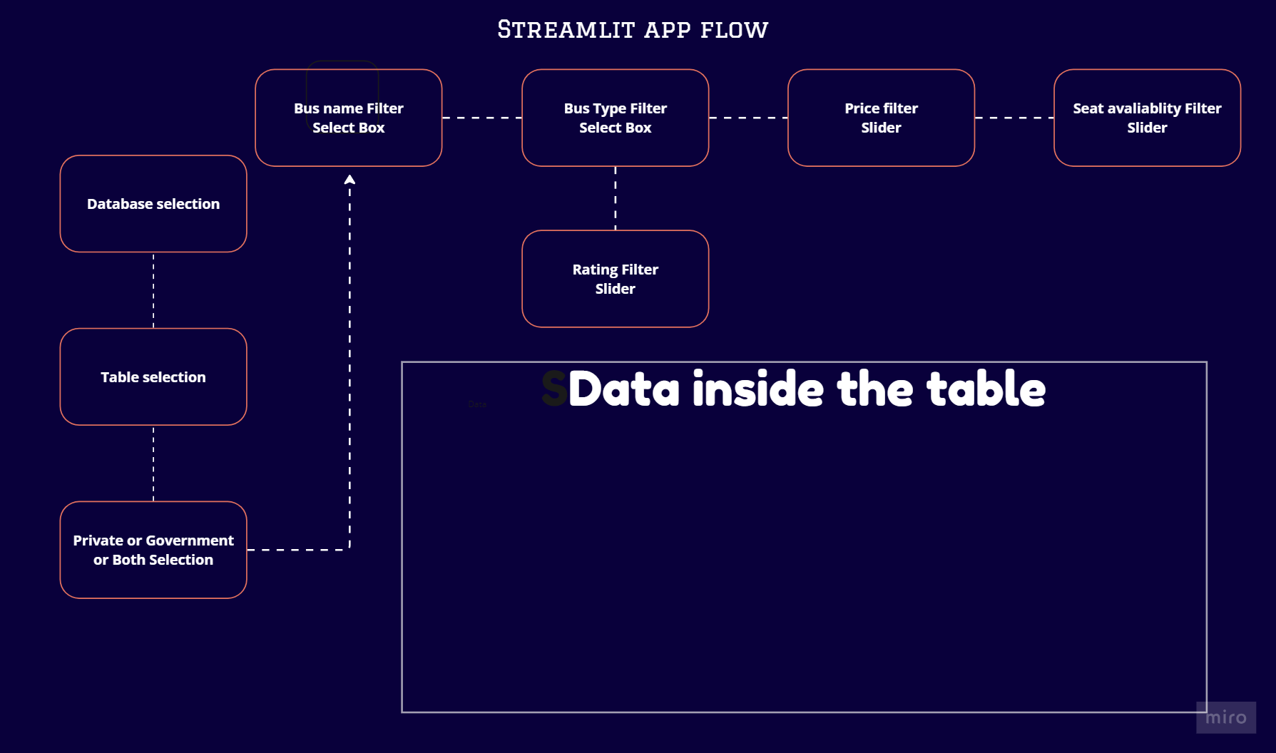

# **Streamlit complete code:**

import streamlit as st

import mysql.connector

import pandas as pd

# MySQL connection setup

mydb = mysql.connector.connect(

host="localhost",

user="root",

password="",

autocommit=True

)

mycursor = mydb.cursor(buffered=True)

# Fetch list of databases

mycursor.execute("SHOW DATABASES")

databases = [db[0] for db in mycursor.fetchall() if db[0] not in ('information_schema', 'mysql', 'performance_schema', 'phpmyadmin', 'test')]

# Streamlit UI

st.set_page_config(layout='centered')

st.title("Welcome to Bus Selector 🚎🚎")

# Custom CSS for styling and hiding slider labels

st.markdown(

"""

<style>

.sidebar .sidebar-content {

background-color: #004E64;

color: #FFFFFF;

border-right: 2px solid #25A18E;

}

.stSelectbox {

background-color: Orange;

color: #fb6107;

border-radius: 5px;

margin-bottom: 10px;

}

.stSelectbox label {

color: #1f2421;

font-weight: bold;

}

.stButton button:hover {

background-color: #25A18E;

transform: scale(1.05);

}

.stDataFrame, .stTable {

background-color: #E5FFF6;

color: #004E64;

border: 3px solid #004E64;

border-radius:4px;

margin-top: 20px;

}

.stSlider .stSliderLabel {

display: none !important;

}

</style>

""",

unsafe_allow_html=True

)

# Sidebar for database and table selection

with st.sidebar:

selected_db = st.selectbox("Select State Transport", databases)

if selected_db:

# Fetch list of tables in the selected database

mycursor.execute(f"USE {selected_db}")

mycursor.execute("SHOW TABLES")

tables = [table[0] for table in mycursor.fetchall()]

selected_table = st.selectbox("Select Route", tables)

if selected_table:

mycursor.execute(f"USE {selected_db}")

mycursor.execute(f"SELECT DISTINCT Bus_Operator_type FROM `{selected_table}`")

Select_operator_Type = [operator_type[0] for operator_type in mycursor.fetchall()]

Select_operator_Type.insert(0, "Both")

Select_operator_Type = st.selectbox("Bus Operator Types", Select_operator_Type, index=0)

# Main content

with st.container():

if selected_db and selected_table and Select_operator_Type:

mycursor.execute(f"SELECT DISTINCT BusName FROM `{selected_table}`")

Name = [column[0] for column in mycursor.fetchall()]

Name.insert(0, "Default") # Add "Default" option to select all

Select_operator_Name = st.selectbox("Bus Name", Name, key="bus_name", index=0)

# Fetch bus types based on selected operator type

if selected_db and selected_table and Select_operator_Type:

mycursor.execute(f"SELECT DISTINCT BusType FROM `{selected_table}`")

Type = [column[0] for column in mycursor.fetchall()]

Type.insert(0, "Default") # Add "Default" option to select all

Select_Bus_Type = st.selectbox("Bus Comfort Type", Type, key="bus_type", index=0)

# Fetch star ratings

if selected_db and selected_table and Select_operator_Type:

mycursor.execute(f"SELECT Star_rating FROM `{selected_table}`")

Rating = [column[0] for column in mycursor.fetchall()]

Star_Rating = st.slider("Ratings", min_value=0.0, max_value=5.0, step=0.1, value=(0.0, 5.0), key="star_rating")

# Fetch price range

if selected_db and selected_table and Select_operator_Type:

mycursor.execute(f"SELECT Price FROM `{selected_table}`")

Price = [column[0] for column in mycursor.fetchall()]

Price = st.slider("Price Range", min_value=0, max_value=5000, step=100, value=(0, 5000), key="price_range")

# Fetch seats available

if selected_db and selected_table and Select_operator_Type:

mycursor.execute(f"SELECT Seats_available FROM `{selected_table}`")

Seat = [column[0] for column in mycursor.fetchall()]

Seats_available = st.slider("Seats Available", min_value=0, max_value=60, step=3, value=(0, 60), key="seats_available")

if selected_db and selected_table and Select_operator_Type and Select_operator_Name and Select_Bus_Type:

with st.spinner('Fetching data...'):

query_conditions = []

if Select_operator_Name != "Default":

query_conditions.append(f"BusName = '{Select_operator_Name}'")

if Select_Bus_Type != "Default":

query_conditions.append(f"BusType = '{Select_Bus_Type}'")

query_conditions.append(f"Star_rating BETWEEN {Star_Rating[0]} AND {Star_Rating[1]}")

query_conditions.append(f"Price BETWEEN {Price[0]} AND {Price[1]}")

query_conditions.append(f"Seats_available BETWEEN {Seats_available[0]} AND {Seats_available[1]}")

if Select_operator_Type != "Both":

query_conditions.append(f"Bus_Operator_type = '{Select_operator_Type}'")

query = f"""

SELECT *, DATE_FORMAT(Departing_Time, '%H:%i:%s') AS Departing_Time_, DATE_FORMAT(Reaching_Time, '%H:%i:%s') AS Reaching_Time_

FROM `{selected_table}`

WHERE {' AND '.join(query_conditions)}

"""

mycursor.execute(query)

data = mycursor.fetchall()

columns = mycursor.column_names

# Convert data to DataFrame without index

df = pd.DataFrame(data, columns=columns)

# Drop old columns

df.drop(['Departing_Time', 'Reaching_Time'], axis=1, inplace=True)

# Set 'id' column as the index

df.set_index('id', inplace=True)

# Display data without index

st.write(f"Buses from {selected_table} are")

st.dataframe(df)

## **Import and Title of the app:**

For using the streamlite I have imported it and I have given a sql connection setup for fetching the required databases I have used a list comprehension which will omit the in built databases

And finally I have given a page layout as a center and the title.

import streamlit as st

import mysql.connector

import pandas as pd

# MySQL connection setup

mydb = mysql.connector.connect(

host="localhost",

user="root",

password="",

autocommit=True

)

mycursor = mydb.cursor(buffered=True)

# Fetch list of databases

mycursor.execute("SHOW DATABASES")

databases = [db[0] for db in mycursor.fetchall() if db[0] not in ('information_schema', 'mysql', 'performance_schema', 'phpmyadmin', 'test')]

# Streamlit UI

st.set_page_config(layout='centered')

st.title("Welcome to Bus Selector 🚎🚎")

## **Page look and its code :**

For enhancing the look of the page I have used this code which will make a good first impression.

# Custom CSS for styling

st.markdown(

"""

<style>

.sidebar .sidebar-content {

background-color: #004E64;

color: #FFFFFF;

border-right: 2px solid #25A18E;

}

.stSelectbox {

background-color: Orange;

color: #fb6107;

border-radius: 5px;

margin-bottom: 10px;

}

.stSelectbox label {

color: #1f2421;

font-weight: bold;

}

.stButton button:hover {

background-color: #25A18E;

transform: scale(1.05);

}

.stDataFrame, .stTable {

background-color: #E5FFF6;

color: #004E64;

border: 3px solid #004E64;

border-radius:4px;

margin-top: 20px;

}

.stSlider .stSliderLabel {

display: none !important;

}

</style>

""",

unsafe_allow_html=True

)

## **What is inside the sidebar:**

As per the flow I have decided to keep the selection of the database,tables and the operator type in the left side as a sidebar so I have put everything i want inside the sidebar and the logic for selecting all the things in the select box is same first we need to filter the what we want in a sql query and put it into the select box.

Here I have additionally added a Both in selecting the operator type because without this it defaultly shows the any one operator with make a table limited that’s why I added this.

with st.sidebar:

selected_db = st.selectbox("Select State Transport", databases)

if selected_db:

# Fetch list of tables in the selected database

mycursor.execute(f"USE {selected_db}")

mycursor.execute("SHOW TABLES")

tables = [table[0] for table in mycursor.fetchall()]

selected_table = st.selectbox("Select Route", tables)

if selected_table:

mycursor.execute(f"USE {selected_db}")

mycursor.execute(f"SELECT DISTINCT Bus_Operator_type FROM `{selected_table}`")

Select_operator_Type = [operator_type[0] for operator_type in mycursor.fetchall()]

Select_operator_Type.insert(0, "Both")

Select_operator_Type = st.selectbox("Bus Operator Types", Select_operator_Type, index=0)

## 

## Main content and logic for choosing it:

After chosen the things in the sidebar I have given 5 different option 2 select box and 3 slider to filter out the buses based on our requirement here also I have added a default in selecting bus name and bus type for the same reason i have given before by default all three in the default conditions and shows all the rows in that table for slider we need to give a three input minimum value, maximum value, and the step value.

with st.container():

if selected_db and selected_table and Select_operator_Type:

mycursor.execute(f"SELECT DISTINCT BusName FROM `{selected_table}`")

Name = [column[0] for column in mycursor.fetchall()]

Name.insert(0, "Default") # Add "Default" option to select all

Select_operator_Name = st.selectbox("Bus Name", Name, key="bus_name", index=0)

# Fetch bus types based on selected operator type

if selected_db and selected_table and Select_operator_Type:

mycursor.execute(f"SELECT DISTINCT BusType FROM `{selected_table}`")

Type = [column[0] for column in mycursor.fetchall()]

Type.insert(0, "Default") # Add "Default" option to select all

Select_Bus_Type = st.selectbox("Bus Comfort Type", Type, key="bus_type", index=0)

# Fetch star ratings

if selected_db and selected_table and Select_operator_Type:

mycursor.execute(f"SELECT Star_rating FROM `{selected_table}`")

Rating = [column[0] for column in mycursor.fetchall()]

Star_Rating = st.slider("Ratings", min_value=0.0, max_value=5.0, step=0.1, value=(0.0, 5.0), key="star_rating")

# Fetch price range

if selected_db and selected_table and Select_operator_Type:

mycursor.execute(f"SELECT Price FROM `{selected_table}`")

Price = [column[0] for column in mycursor.fetchall()]

Price = st.slider("Price Range", min_value=0, max_value=5000, step=100, value=(0, 5000), key="price_range")

# Fetch seats available

if selected_db and selected_table and Select_operator_Type:

mycursor.execute(f"SELECT Seats_available FROM `{selected_table}`")

Seat = [column[0] for column in mycursor.fetchall()]

Seats_available = st.slider("Seats Available", min_value=0, max_value=60, step=3, value=(0, 60), key="seats_available")

## 

## **Logic behind the selection:**

By default the app will show the entire rows but if something is selected means that query is appended inside the query conditions and reflected in the table as per our selection or sliding those conditions will work only the default and both are not selected and finally the resulted query is in the mycursor and i have formatted a reaching time and departing time because it is converting into a hours that's why I used formatting and i have also fetched a column names to display it.

if selected_db and selected_table and Select_operator_Type and Select_operator_Name and Select_Bus_Type:

with st.spinner('Fetching data...'):

query_conditions = []

if Select_operator_Name != "Default":

query_conditions.append(f"BusName = '{Select_operator_Name}'")

if Select_Bus_Type != "Default":

query_conditions.append(f"BusType = '{Select_Bus_Type}'")

query_conditions.append(f"Star_rating BETWEEN {Star_Rating[0]} AND {Star_Rating[1]}")

query_conditions.append(f"Price BETWEEN {Price[0]} AND {Price[1]}")

query_conditions.append(f"Seats_available BETWEEN {Seats_available[0]} AND {Seats_available[1]}")

if Select_operator_Type != "Both":

query_conditions.append(f"Bus_Operator_type = '{Select_operator_Type}'")

query = f"""

SELECT *, DATE_FORMAT(Departing_Time, '%H:%i:%s') AS Departing_Time_, DATE_FORMAT(Reaching_Time, '%H:%i:%s') AS Reaching_Time_

FROM `{selected_table}`

WHERE {' AND '.join(query_conditions)}

"""

mycursor.execute(query)

data = mycursor.fetchall()

columns = mycursor.column_names

## **Final pandas integration for displaying the resulted table:**

And finally I have inserted the resulting data into a pandas dataframe and I have dropped an old departing and reaching time column and I have assigned an id as an index column so the result will be shown as I expected.

df = pd.DataFrame(data, columns=columns)

# Drop old columns

df.drop(['Departing_Time', 'Reaching_Time'], axis=1, inplace=True)

# Set 'id' column as the index

df.set_index('id', inplace=True)

# Display data without index

st.write(f"Buses from {selected_table} are")

st.dataframe(df)

# **App using demo:**

## **Filtering the buses based on the State:**

For selecting the state bus that you needed you can click the state bus transport and the dropdown box will appear then you can select a required state transport.

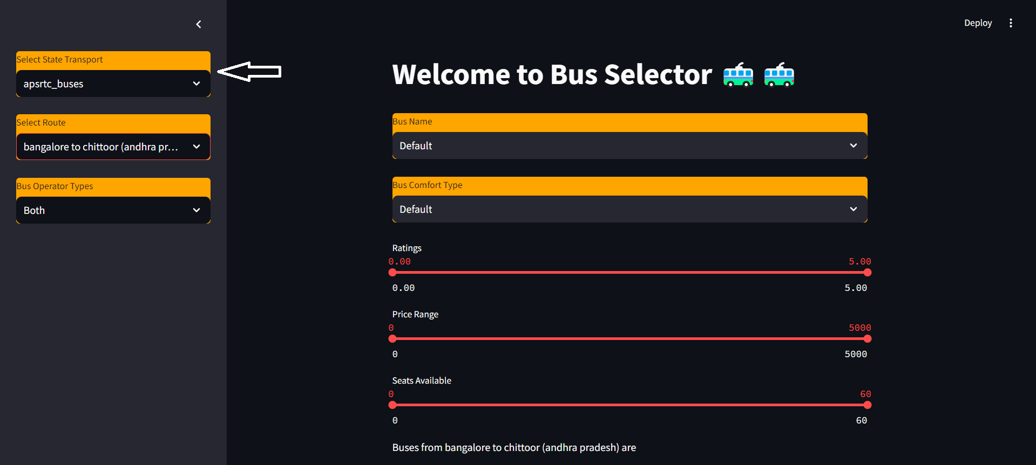

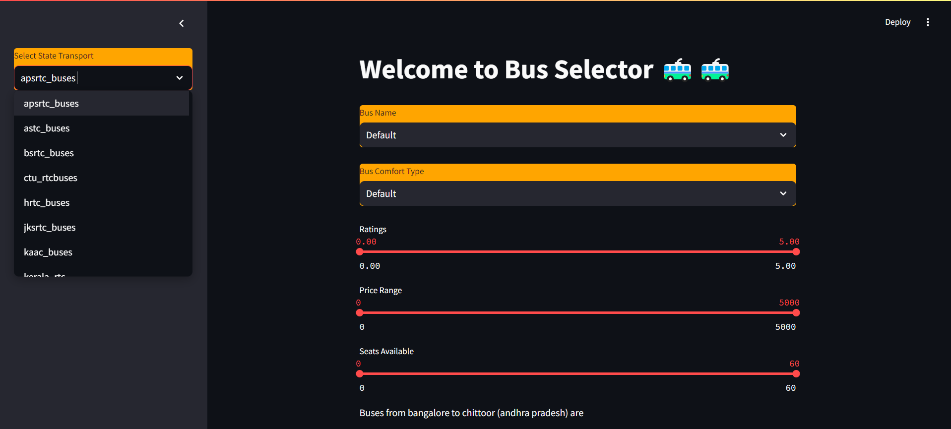

## **Filtering the buses based on the Route:**

For selecting the Route that you need you can click the Select Route and the dropdown box will appear then you can select a required Route.

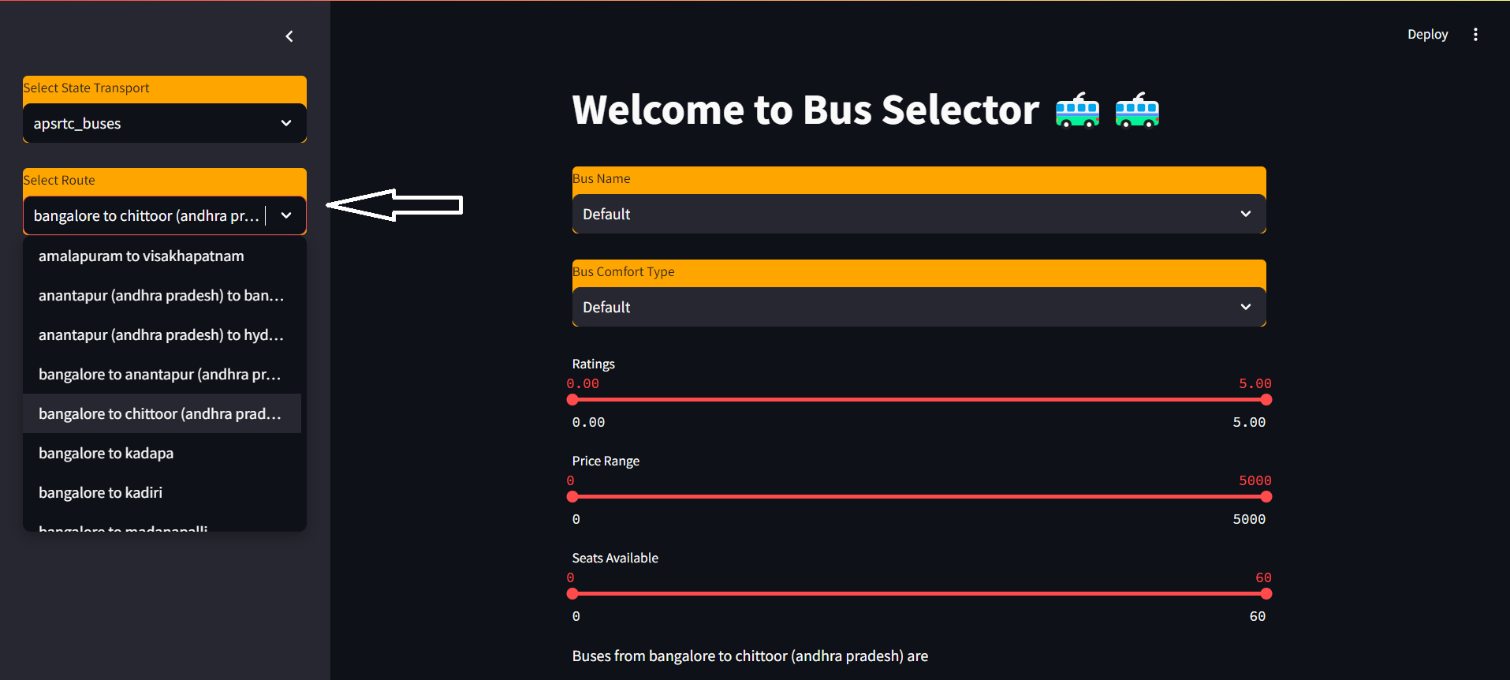

## **Filtering the buses based on the Service provider:**

For selecting the service provider that you need you can click the Bus operator type and the dropdown box will appear then you can select a service provider.

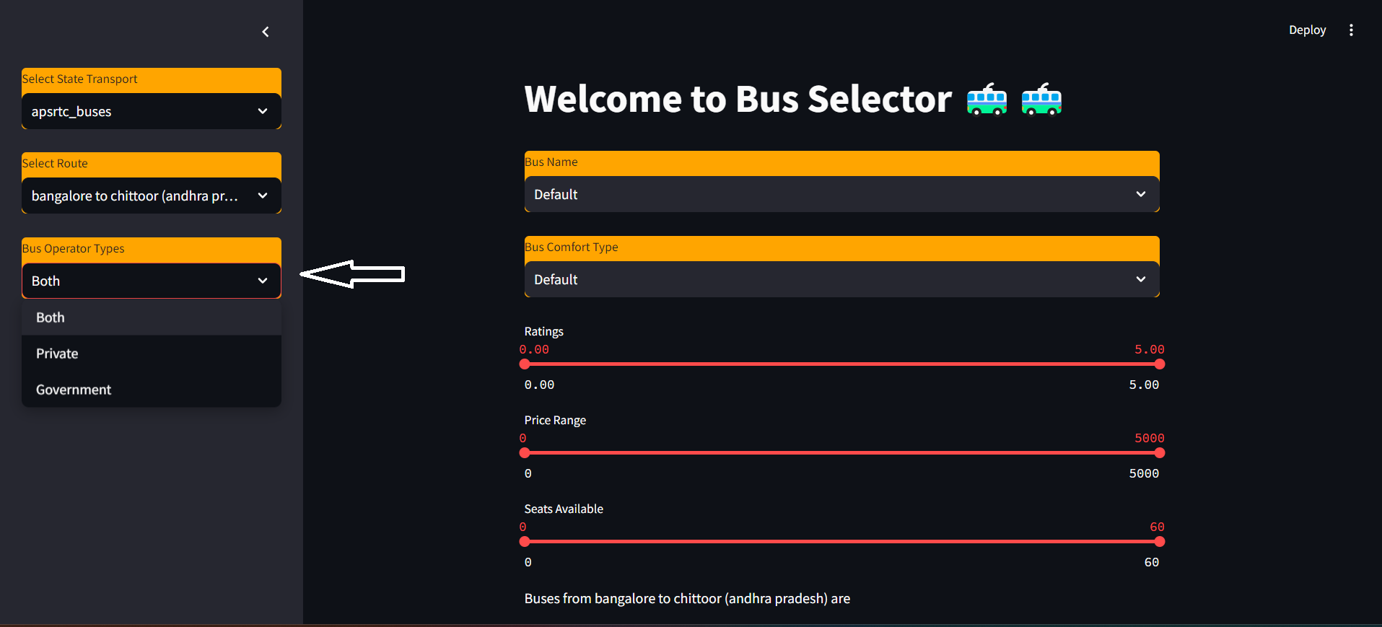

## **Filters in main page:**

There are five filters for filtering out the buses as per your needs you can filter it using bus type, bus name , rating , price and seat available.

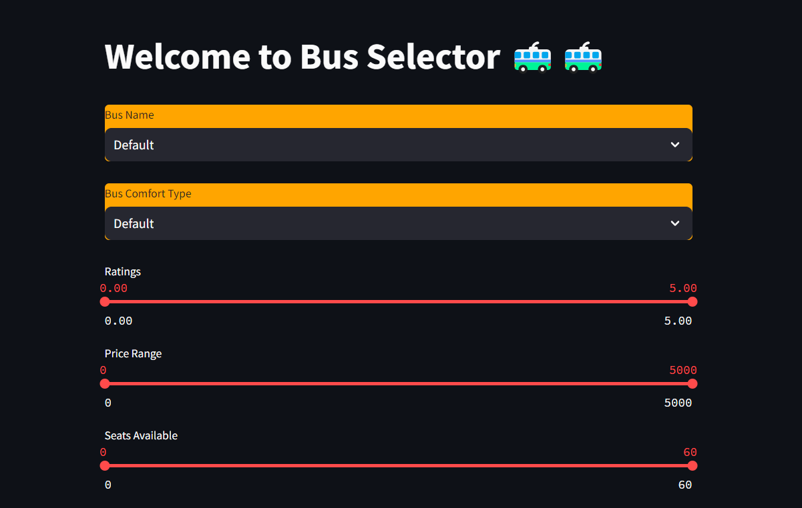

## **Final table look:**

Finally the table looks like this.The results are completely based on the filter you have applied.

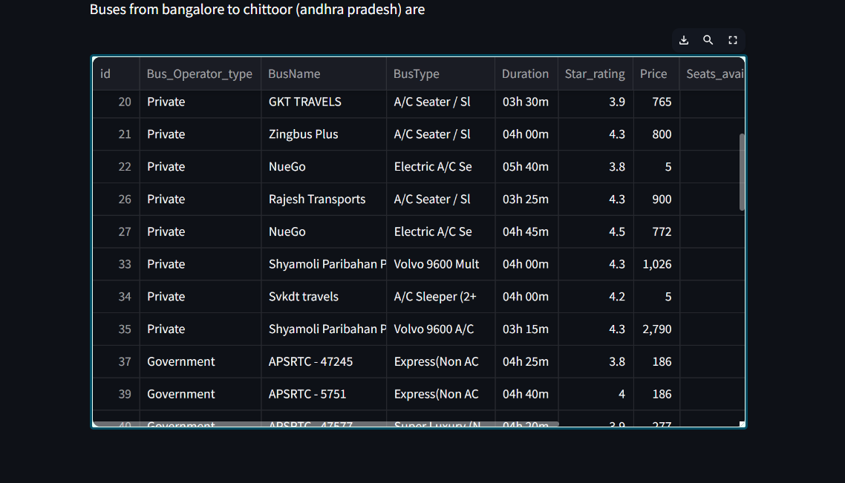

## 

## **Full final demo video:**

[App Demo](https://drive.google.com/file/d/1t6ULqU248tRQrwnQpO8QAg8p48bbC_-r/view?usp=drive_link)